High POLYMERS 20-03-2020

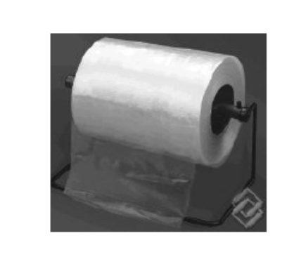
Definition: “Polymers are carbonaceous materials with large molecular masses obtained by covalent linkages of several small repeating units called monomers.
Polymerization: “Polymerization is union of two or more smaller and simpler molecules of similar or different types with or without elimination of any part of the molecule resulting in the formation of new covalent linkages.”
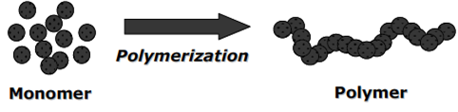

Types of polymerization: There are two types of polymerization- Addition polymerization and Condensation polymerization.
Examples: n CH₂ = CH₂ (ethylene) -(addition polym) → -(CH₂ – CH₂)-_{n} (polythene)
n OH-(CH₂)_{a}- OH + n HOOC-(CH₂)_{b}-COOH → (cond.polym) → -[O-(CH₂)_{a}-O- OC-(CH₂)_{b}-
CO]_{n}- + nH₂O
bi-functional alcohol bi-functional acid Polyester
- Methods of Addition Polymerization: Addition polymerization is carried out using four different methods. They are:
a) Bulk or Mass polymerization b) Solution polymerization c) Suspension polymerization d) Emulsion polymerization.
- Bulk or Mass Polymerization:
Method: In this method, monomer is taken in the liquid state and a small amount of an initiator is dissolved in it. The mixture is heated or radiated with constant stirring to get the polymer.
Monomer + Initiator (dissolved in monomer) → heat/radiate → stir → Polymer Advantages: 1. Technique is simple
2. Pure polymer is obtained
3. Products have high optical clarity Disadvantages: 1. The reaction is exothermic
2. Uncontrolled temperature leads to cross linkages, branching, discoloration and
thermal degradation. Applications: Used for making polystyrene, poly methyl methacrylate and PVC in the form of sheets, rods and sheets.
- Solution Polymerization
Method: In this method an inert solvent in which both the monomer and the polymer dissolve is taken. The initiator is dissolved and the mixture is heated with stirring. The polymer obtained is isolated by evaporating the solvent.
Monomer in a solvent + Initiator dissolved → (heat/stir) Polymer in solvent→ (Evaporate solvent)- → Polymer Advantages : 1. The solvent will reduce the viscosity of reactants
2. It can be stirred well
3. Heat dissipation is efficient. Disadvantages: 1. Polymer obtained is not pure
2. High molecular weight polymers are not obtained Applications: Used in the preparation of poly acrylo-nitrile and poly isobutylene polymers.
- Suspension Polymerization
Method: In this method, the monomer is suspended in water with a stabilizer like gelatin to avoid coagulation. The initiator is dissolved in suspension. The reaction mixture is continuously stirred to get the polymer in the form of globules.
Monomer + Stabilizer + Initiator --- (Stir well → Polymer ( suspension (dissolved (in suspension, in globule form)
in water) in suspension)
Advantages: 1. Reaction is 100% complete
2. Molecular mass distribution is uniform
3. High purity of product
4. Products are obtained in the form of beads and separation is easy
5. Process is economical Disadvantages: 1. Method is applicable only to water soluble monomers
2. It is difficult to control size of the particle formed. Applications: Used in the manufacture of polystyrene, styrene – divinyl benzene co-polymer

- Emulsion Polymerization
Method: In this method, water insoluble monomer and water soluble initiator such as H₂O₂ are used along with an emulsifying agent. The mixture is agitated vigorously to get the polymer. The pure polymer is isolated by using a de-emulsifier.
Monomer (water insoluble) + Initiator(water soluble) + Emulsifier → (stir vigorously) →
Polymer (in emulsion)- → (de-emulsifier)- → Polymer
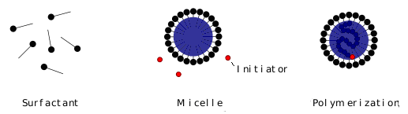
Advantages: 1. Rate of polymerization is high
2. Polymers of uniform molecular mass are obtained
3. Heat dissipation is efficient Disadvantages: 1. Less emulsifying agent if added polymers of lesser molecular masses are obtained.
2. Method needs additional cleaning to remove coated emulsifier
3. Very rapid agitation is required to get the polymer Applications: Widely used for the industrial manufacture of polyvinyl chloride, poly chloroprene and poly butadiene.
- GLASS TRANSITION TEMPERATURE (Tg)
Unlike in metal article fabrication, the polymers are not melted to the liquid form to fabricate, but heated just to its softening temperature. This is referred to as glass transition temperature.
Definition of Tg: “The temperature at which a polymer abruptly transforms from glassy state ( hard state) to a rubbery state (soft state) is called Glass Transition Temperature and denoted by Tg.”
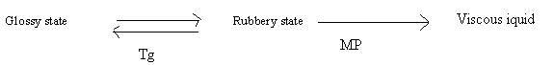
This transition from hard solid state to soft and flexible state corresponds to the beginning of chain motion or rotation about C-C single bonds in polymers. Below Tg polymer is said to be in frozen state.
Parameters affecting Tg:

a) Chain flexibility: Free rotational motion imparts flexibility. Rigid structure in the polymer chain or with bulky side chains hinder the freedom of rotation and decrease in flexibility and increase Tg. Hence, highly flexible polymer will have low Tg value.
Ex; T_{g} of polyethylene is -110 ⁰C
T_{g} of polystyrene is 100 ⁰C

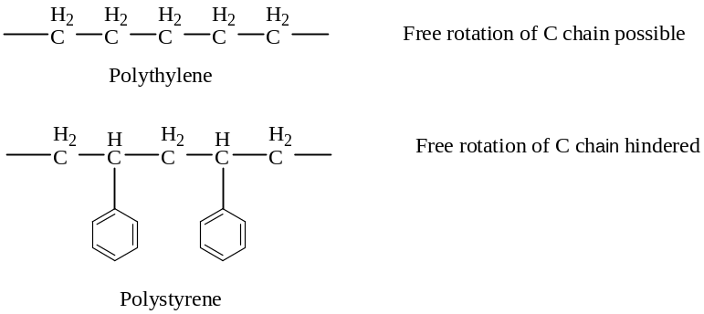

b) Intermolecular forces: Presence of large number of polar groups in molecular chain lead to strong inter molecular forces such as hydrogen bonding, Van der Waals forces etc., and they restrict molecular mobility and hence increase Tg. Hence higher the intermolecular forces higher will be the Tg.
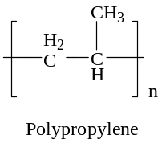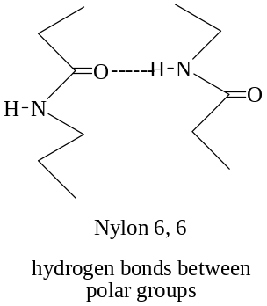

c) Branching and Cross linking: A high degree of branching and cross linking in the polymer, brings the molecular chains closer, lowers the free volume reducing chain mobility. This will increase Tg. Hence highly branched and cross liked polymers will have higher Tg.
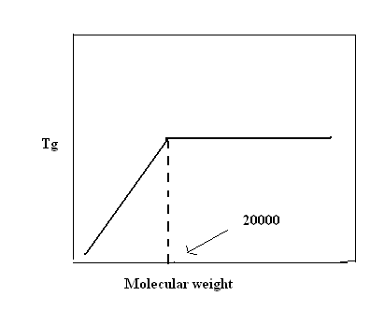
- Molecular weight: High molecular weight polymers have greater density and increase in Tg. However, Tg is not significantly affected by the molecular mass if the degree of polymerization above 250 or molecular mass is above 20000. (graph)

Significance of Tg:
i) Tg can used to evaluate flexibility of a polymer and predict its response to mechanical stress.
ii) Many polymers change their other physical properties like viscosity, elastic nature also at Tg. Hence use of a polymer at Tg with respect to other properties can be decided.
iii) Different fabrication works like moulding, shaping, calendaring etc., can be conveniently carried out with knowledge of Tg, as the entire machinery can be pre-set to that temperature.
- Synthesis, Properties, Applications of TEFLON (Poly tetra fluoro ethylene – PTFE)

Synthesis: It is made by addition polymerization of water emulsion of Tetra fluoro ethylene in aqueous or alkaline medium at 55-240º C in presence of Benzoyl peroxide as catalyst at 1000 PSI pressure.
n CF₂ = CF₂ → -(CF₂ – CF ₂)-_{n}
Tetrafluoro ethylene PTFE

Properties: 1. High degree of crystallinity of 93-98 %, high melting point of 327º C and high density of 2.3 g cm ^{-3.}
2. Insoluble in most solvents and chemicals
3. Not wetted by oil and water
4. High thermal stability, strength and insulating properties.
Applications: 1. For insulation in motors, transformers coil and capacitors
2. Making industrial filters, gaskets and belts
3. As non-sticky coating on bakery trays and frying pans
4. As anti- corrosive coating
5. As non- lubricated bearing.

- Synthesis, Properties, Applications of PLEXI GLASS ( Poly methyl methacrylate ) PMMA

Synthesis: it is made by bulk or emulsion polymerization of Methyl meth acrylate in presence of H₂O₂ as initiator at 60-70 º C under atmospheric pressure.
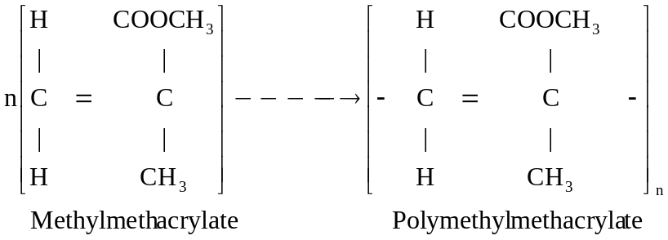
Methyl acrylate PMMA

Properties: 1. Highly transparent, thermoplastic, softening at 120º C.
2. Excellent optical properties
3. Not affected by sunlight but affected by many chemicals and some organic solvents
4. Has good dimensional stability.

Applications: 1. For making lenses, aircraft parts and light fixtures
2. Used in jewelry, wind screens and TV screens.
3. For making artificial eyes and denture.
4. Used in emulsion paints.

      - Conducting Polymers
Most of the polymers are insulators, with desirable properties such as light weight, processabllity, durability, and low cost. By designing the molecular structures of polymers, chemists have developed new materials that exhibit electrical conductivities comparable to metals while retaining the advantages of polymers. Generally, these electrically conducting polymers are composed of conjugated polymer chains with л-electrons delocalized along the backbone. The polymers are converted to the electrically conductive, or doped, form via oxidation or reduction reactions that create delocalized charge carriers. Charge balance is accomplished by incorporating an oppositely charged counter ion into the polymer matrix.
An organic polymer with highly delocalized pi-electron system, having electrical conductance of the order of a conductor is called a conducting polymer.
Synthesis:
An organic polymer can be converted into a conducting polymer if it has
 Linear structure
 Extensive conjugation in polymeric back bone (pi-back bone)
The conducting polymers are synthesized by doping, in which charged species are introduced in organic polymers having pi-back bone. The important doping reactions are:
- Oxidative doping (p-doping)
- Reduction doping (n-doping)
- Protonic acid doping (p-doping)
- Normally electron in a polymer are localized and do not take part in conducting but doping can create delocalized electrons and responsible for conduction.
Mechanism of conduction:
Band theory of solids has been used to explain the conduction mechanism in conducting polymers. The neutral polymer (insulator) be transferred into a conductor by doping with electron donar (reducing dopant such as sodium naphthalide) or an electron acceptor (like iodine vapor, FeCl₃, iodine in CCl₄, HBF₄, perchloric acid and benoquinone)
The removal of an electron from the polymer pi-back bone using a suitable oxidizing agent leads to the formation of delocalized radical ion called polaron.
A second oxidation of a chain containing polaron, followed by radical recombination yields two charge carriers on each chain. The positive charge sites on the polymer chains are compensated by anions (I₃⁻ ) formed by the oxidizing agent during doping.
The delocalized positive charges on the polymer chain are mobile, not the dopant anions. Thus, these delocalized positive charges are current carries for conduction. These charges must move from chain to chain as well as along the chain for bulk conduction. On doping polyacetylene using iodine in CCl₄, for partial oxidation, the conductivity increases from 10⁻⁵ S. cm⁻¹ to 10³-10⁵ S.cm⁻¹.
